**f. 31r**

¶ca*pitulum* 27

n*ota* .;.

**f. 31v**

:•

[a noone

**f. 32r**

c___

**f. 32v**

¶ca*pitulum* 28•

**f. 33r**

____

|__

n*ota*

she þen

C

þei^

**f. 33v**

so fa RM

& f Norto*n*

of Wakenes

of þ*e* passyo*n*

e passyon

[no*ta* de clamor .;.

>

**f. 34r**

n*ota*

¶

**f. 34v**

¶

**f. 35r**

n*ota*

no*ta*

¶ca*pitulum* •29•

**f. 35v**

¶

**f. 36r**

n*ota*

**f. 36v**

|by • & by

**f. 37r**

n*ota*

**f. 37v**

[no*ta* de vestura

¶

¶

a*n*k*er*]

**f. 38r**

¶

**f. 38v**

n*ota*

¶ca*pitulum* •31•

ih*esu* c*ris*t e*st* amor • t*us*

**f. 39r**

[unreadable]

[flore*n*t

**f. 39v**

¶ca*pitulum* 32•

**f. 40r**

[no*ta* de co*n*fessione

.;.

Ioh*an*

)

n*ota*

no*ta* b*e*n*e*

¶

I E •

no*ta*

loue

**f. 40v**

no*ta* mirab*i*le

q*uo*d se*quitur* .;.

i*n* Ro

¶ca*pitulum* •33•

¶

no*ta*

**f. 41r**

[unreadable letters?]

[smear}

___]

n*ota*

**f. 41v**

sade she

¶ca*pitulum* 34

**f. 42r**

/[A proud prist

¶ca*pitulum* [35]

¶

no*ta*

A meke

hanswer

(

/

**f. 42v**

¶

**f. 43r**

de despo*n*sa[cio]ne

ei*us* ad d*eu*m p*at*re*m*

**f. 43v**

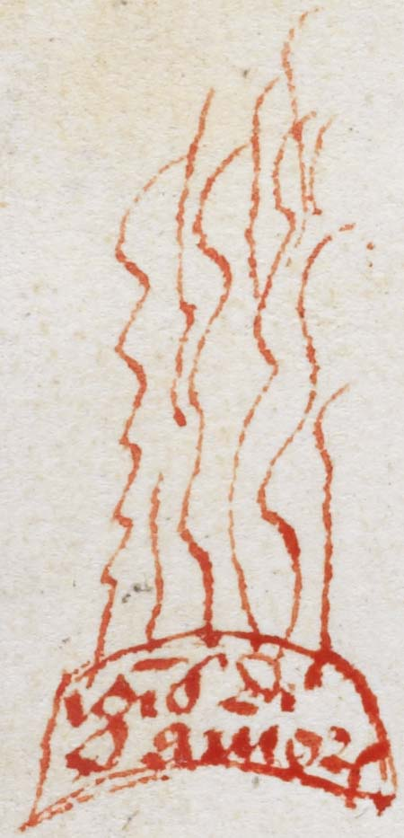

[ig*n*is d*ivin*i

amor*is*]

so s• R• ha*m*pall •

pr

¶

**f. 44r**

¶ca*pitulum* 36•

n*ota*

¶

**f. 44v**

¶

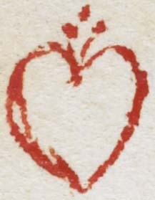

¶ca*pitulum* 37 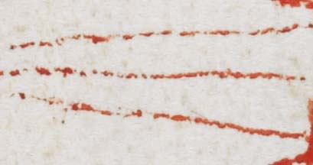

**f. 45r**

¶ca*pitulum* •38•

**f. 45v**

¶